Data Analyst project1
Name: Aleke James
Task: Data cleaning and preparation
Tools used: Python (pandas, matplotlib. pyplot)
Date: 17 June 17, 2026

Introduction
This report documents how project 1 of data analyst was done. Below is a step-by-step procedure using python ( pandas and matplotlib.pyplot)
Step1: loading the dataset
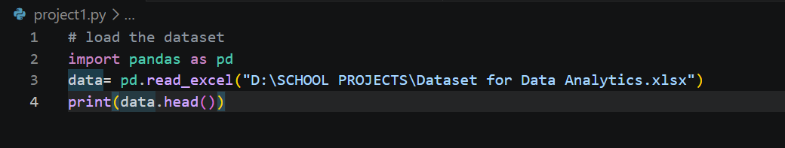
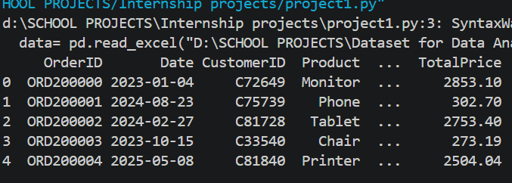
Step2: Data cleaning
Data cleaning is the process of removing noise and adding important details to the dataset to make it ready for modeling and prediction for quality and reliable results.
Below are some processes that was done on the data to make it clean
- Checking and handling missing values
- Missing values were identified in Coupon code column. I think this where people did not use coupon codes
- Since the blanks are many, I decided to replace the blanks with “ no coupon” to make the column complete because these blanks can cause wrong results during analysis.

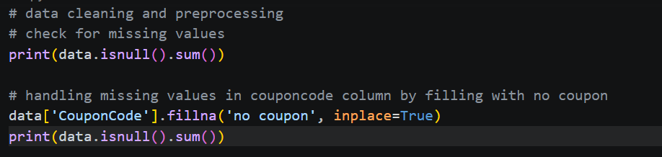
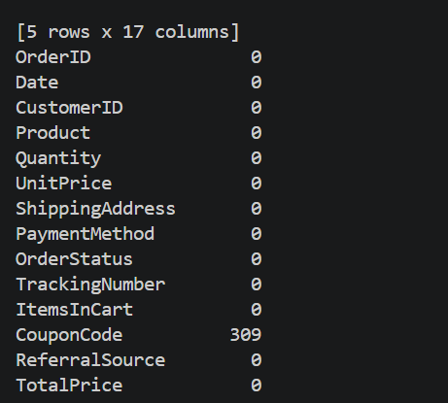
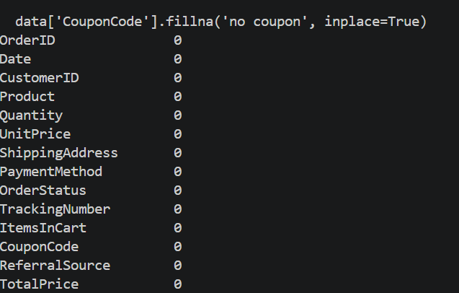

- Checking for data format
- This process makes sure that all the variables are in their correct data format for python to treat them correctly.
- 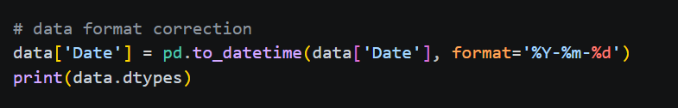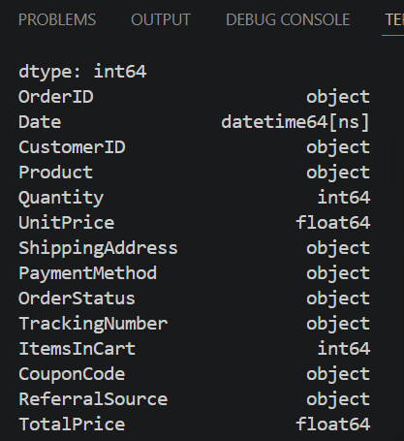

- checking for duplicates
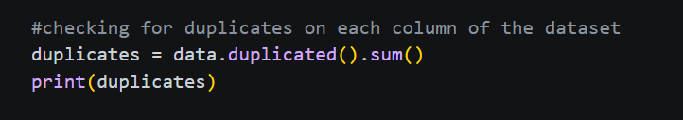
I found that there was no duplicates but when I was going through the dataset, I found that some customerID were repeated (duplicate) so I checked for duplicate in customerID column.

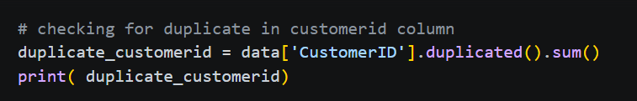
After checking the customerID column, I found 11 duplicates, but I kept them because they are significant not error (they show regular customers) and without them might cause data loss.

The next checked column was orderID and found out that there is no duplicate.
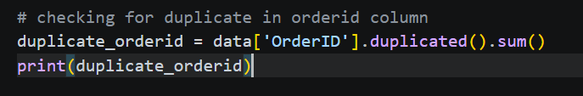

- Confirming that all the variables are in their correct format and I found that they are in the correct format.
- Finally, checking for outliers using boxplot and IQR method and I found outliers in Total Price column, but I kept them because they represent valid small or larger transactions since the products have different prices and removing them might affect the revenue.

Conclusion
This task was not easy since it needs to be keen in every detail and understanding the dataset else you might end up deleting everything identified that can read to errors and data loss that’s why this process/stage is very important.

